Images for design inspo
here are some design inspo you can fetch some typography and color palette from it. as it is one page long we will move to 5 pages as we discuss but the theme of website must be like it
the fonts of site must deliver rich elegant and premium vibes. the color palette of site must be like soft warm which give the premium and home vibes
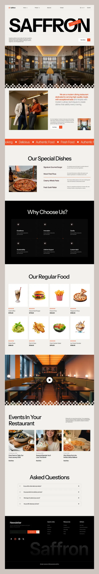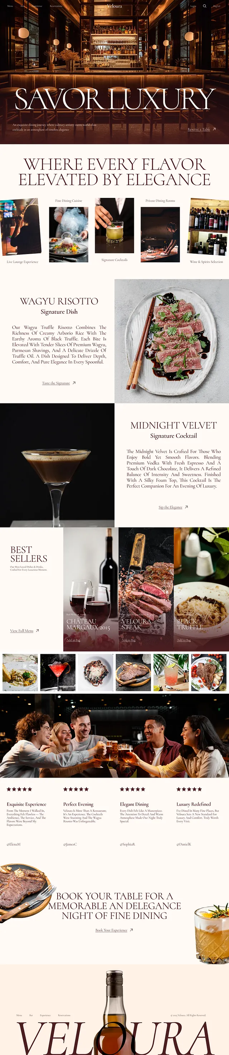
For menu of site we will use these menu list and with that we will move forward to the site demo
Here's a complete demo menu you can use.
🍛 Desi Cuisine
BBQ Specials
Chicken Tikka
Chicken Malai Boti
Chicken Seekh Kebab
Beef Seekh Kebab
Chicken Bihari Boti
Beef Bihari Boti
Mutton Chops
Chicken Reshmi Kebab
Grilled Fish
BBQ Platter
Karahi
Chicken Karahi
Chicken White Karahi
Chicken Achari Karahi
Mutton Karahi
Beef Karahi
Peshawari Karahi
Namkeen Karahi
Handi
Chicken Handi
Chicken Cheese Handi
Chicken Green Handi
Chicken Afghani Handi
Mutton Handi
Beef Handi
Traditional Curries
Butter Chicken
Chicken Qorma
Mutton Qorma
Nihari
Paya
Haleem
Chicken Jalfrezi
Chicken Ginger
Daal Makhni
Mixed Vegetable Curry
Rice
Chicken Biryani
Beef Biryani
Mutton Biryani
Sindhi Biryani
Chicken Pulao
Mutton Pulao
Fried Rice
Egg Fried Rice
Naan & Bread
Plain Naan
Garlic Naan
Roghni Naan
Cheese Naan
Tandoori Roti
Kulcha
Paratha
🍕 Italian Cuisine
Pizza
Margherita
Pepperoni
BBQ Chicken
Chicken Fajita
Supreme
Four Cheese
Veggie Delight
Meat Lovers
Alfredo Chicken Pizza
Garlic Chicken Pizza
Pasta
Chicken Alfredo
Penne Arrabbiata
Spaghetti Bolognese
Creamy Mushroom Pasta
Lasagna
Seafood Pasta
Mac & Cheese
Risotto
Mushroom Risotto
Chicken Parmesan Risotto
Seafood Risotto
Appetizers
Garlic Bread
Bruschetta
Mozzarella Sticks
Cheese Balls
Italian Fries
Chicken Wings
Salads
Caesar Salad
Greek Salad
Italian Garden Salad
Chicken Avocado Salad
🥙 Arabic Cuisine
Grills
Chicken Shawarma Plate
Beef Shawarma Plate
Mixed Grill
Chicken Shish Taouk
Beef Kofta
Lamb Kofta
Lamb Chops
Grilled Chicken
Rice Dishes
Chicken Mandi
Mutton Mandi
Chicken Kabsa
Mutton Kabsa
Chicken Bukhari Rice
Lamb Ouzi
Mezze
Hummus
Mutabbal
Baba Ghanoush
Labneh
Muhammara
Stuffed Grape Leaves
Wraps
Chicken Shawarma Wrap
Beef Shawarma Wrap
Falafel Wrap
Chicken Arayes
Fresh Bread
Arabic Bread
Pita Bread
Saj Bread
Khubz
🍰 Desserts
Pakistani Sweets
Gulab Jamun
Ras Malai
Kheer
Gajar Ka Halwa
Suji Halwa
Shahi Tukray
Rabri
Jalebi
Cakes
Chocolate Fudge Cake
Red Velvet Cake
Lotus Biscoff Cake
Tiramisu
Cheesecake
Black Forest Cake
Nutella Cake
Ice Cream
Vanilla
Chocolate
Strawberry
Mango
Pistachio
Cookies & Cream
Salted Caramel
Arabic Desserts
Kunafa
Baklava
Basbousa
Umm Ali
Qatayef
Date Cake
Italian Desserts
Tiramisu
Panna Cotta
Cannoli
Affogato
Gelato
Chocolate Lava Cake
🥤 Beverages
Hot Drinks
Espresso
Cappuccino
Latte
Americano
Hot Chocolate
Green Tea
Kashmiri Chai
Cold Drinks
Coca-Cola
Pepsi
Sprite
7UP
Fanta
Mountain Dew
Fresh Juices
Orange
Apple
Mango
Watermelon
Pineapple
Pomegranate
Mocktails
Blue Lagoon
Mint Margarita
Strawberry Mojito
Passion Fruit Cooler
Tropical Punch
Lemon Mint
Milkshakes
Oreo Shake
Chocolate Shake
Vanilla Shake
Strawberry Shake
KitKat Shake
Lotus Biscoff Shake
☕ Specialty Coffee
Espresso
Double Espresso
Cappuccino
Latte
Flat White
Mocha
Caramel Latte
Hazelnut Latte
Spanish Latte
Cold Brew
Iced Americano
Iced Latte

For flow of user on site we will go like
When user open the site he see the navbar with
Home MENU(MASHRIQ) ABOUT US(STORY) WHY US (TRUST) CONTACT US
The home section will move to the details of restaurant with a CTA of book a table or sides of mashriq
In menu there must be options of selecting cuisine DESI ITALIAN ARABIC with suboptions of main starter sides appetizer beverages desserts.
In about section there must be a story of how we started and what is out aim
In why us section site delivers why choose us over others
And in the last contact us they can book a table or leave a review

For admin view he can change the menu like what’s is menu and is available right now or not further more other roles like manager and employee have separate role with their respective authority where in their own space they can work.
For now we will stick to just the admin panel of seeing bookings and labelling it as confirmed or rejected then we will move to other roles lets just stick to it

